Experiment No. | 5
Aim | Fractional KnapSack Algorithm(Greedy Approach)
Name | Sakshi D Lonare
UID No. | 2021300069
Class & Division | Comps SE A

Algorithm:-

- Sort the given array of items according to weight / value(W /V) ratio in descending order.
Start adding the item with the maximum W / V ratio.
Add the whole item, if the current weight is less than the capacity, else, add a portion of the item to the knapsack.
Stop, when all the items have been considered and the total weight becomes equal to the weight of the given knapsack.

Program:-
#include <stdio.h>

void main()
{
int W,curr_w,maxi,n;
int used[10];
int weight[10];
int val[10];
float tot_val;
int i;

printf("Enter the knapsack capacity:\n");
scanf("%d",&W);
printf("Enter the no of items:\n");
scanf("%d",&n);
printf("Enter the weight and value for %d item:\n",n);
for(i=0;i<n;i++)
{
printf("Weight %d\t",i+1);
scanf("%d",&weight[i]);
printf("Value %d\t",i+1);
scanf("%d",&val[i]);
}

printf("Weight\n%d\t Value\n%d\t",weight[i],val[i]);

for(i=0;i<n;++i)
{
used[i]=0; //since no ith item has been used
}

curr_w=W;
while(curr_w>0)
{
maxi=-1;//finding the best item to put in bag
for(i=0;i<n;++i)
{
if((used[i]==0)&&((maxi==-1) || ((float)val[i]/weight[i] > (float)val[maxi]/weight[maxi])))
{
maxi=i;
}
}
used[maxi]=1; //item already in the bag
curr_w-=weight[maxi];//one one item going to be less if put in the bag
tot_val+=val[maxi];

if(curr_w>=0)
{
printf("Added item %d with (%d kg,%d Rs) completely in bag\n",maxi+1,weight[maxi],val[maxi]);
printf("Capacity left: %d\n",curr_w);
}
else{
printf("Added %d percent of item %d with(%d kg, %d Rs) in the bag\n",(int)((1+(float)curr_w/weight[maxi])*100),maxi+1,weight[maxi], val[maxi]);
tot_val -= val[maxi];
tot_val += (1 + (float)curr_w/weight[maxi]) * val[maxi]; //adding that percent of value in the bag as left
}
}
printf("Filled the bag with objects worth %.2f Rs\n", tot_val);
}

Output:-
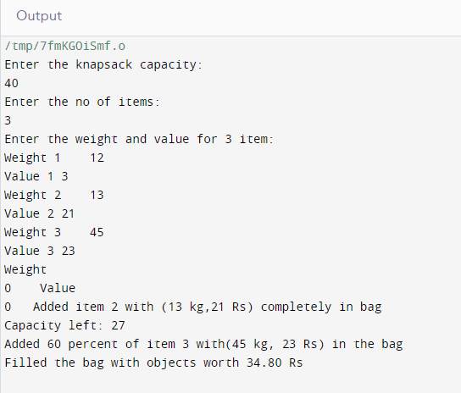

Conclusion: Learnt the implementation and algorithm for fractional knapsack method. The greedy approach is a useful method for solving the fractional knapsack problem, but it is important to consider its limitations and potential drawbacks, such as its inability to handle certain cases where the optimal solution is not achieved.

